**Question A**

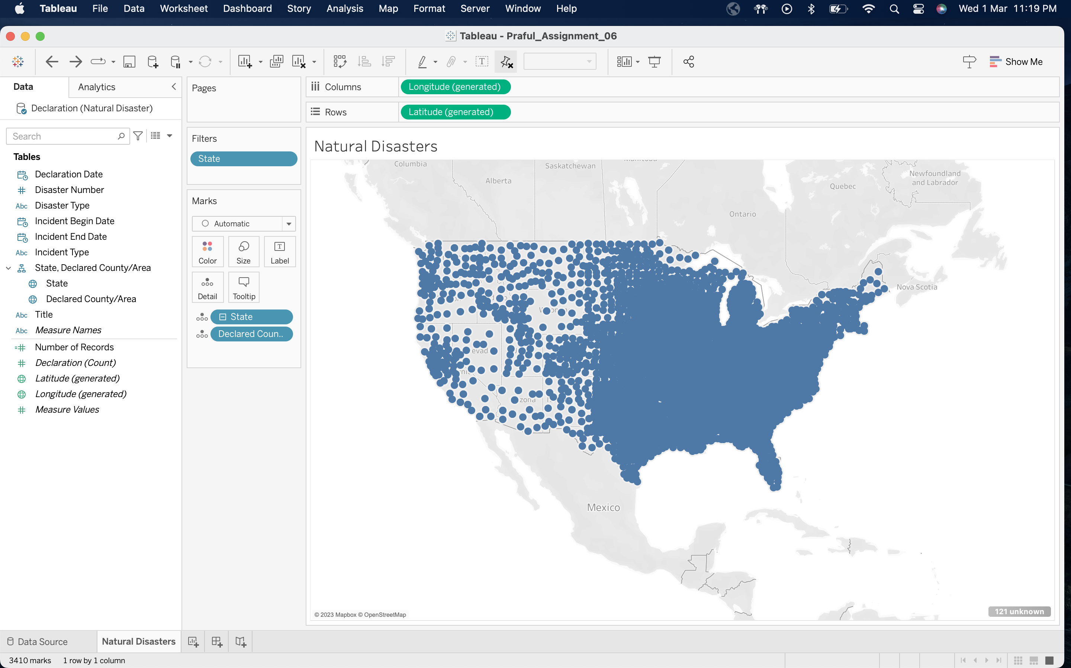

**Question B**

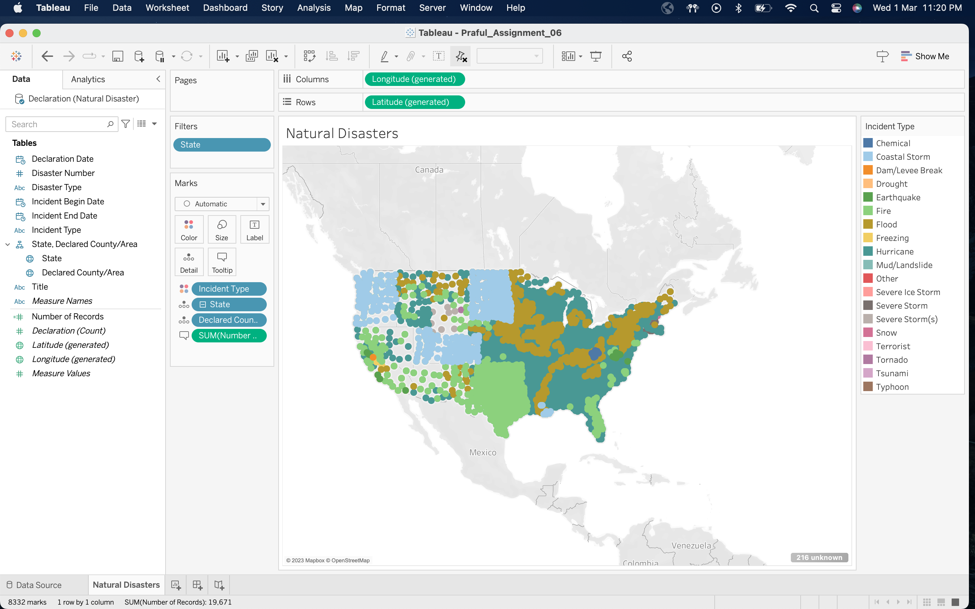

**Question C**

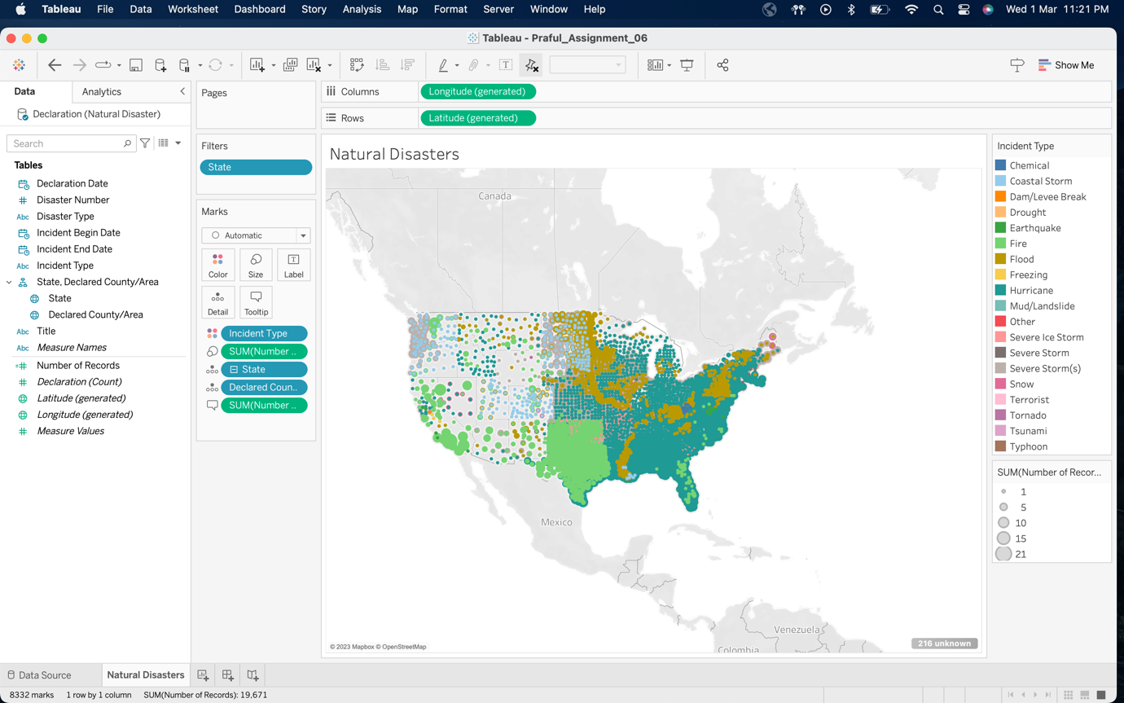

**Question D**

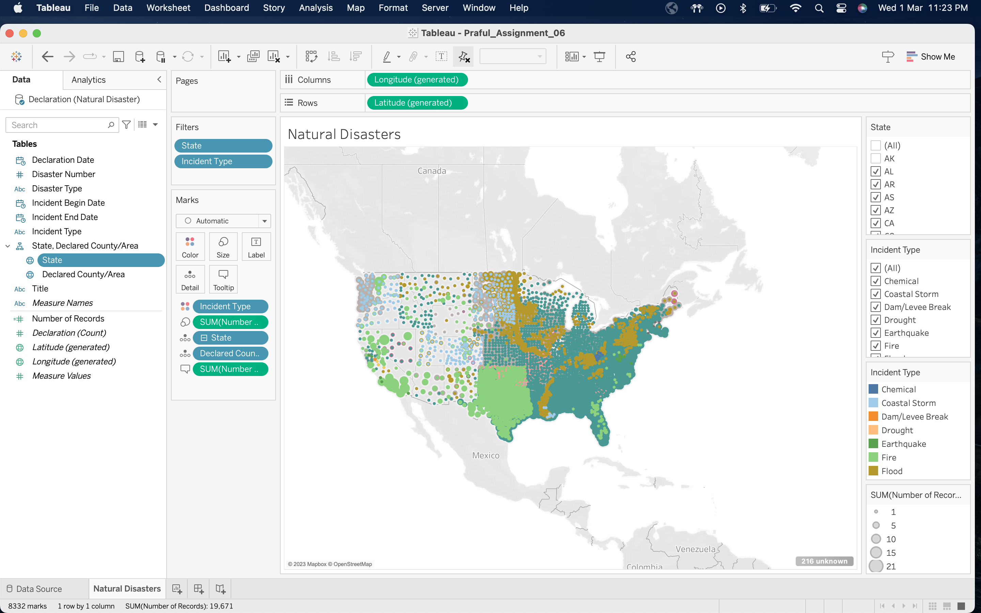

**Question E**

The most prevalent disaster in **Texas** is **Fire** and the most prevalent disaster in **Alabama** is **Hurricane**.

**Question F**

We cannot see Alaska and Hawaii in the map since we have filtered it out from the visualization in Step 4.

**Question G**

We visually encoded different disasters using **Color**.

**Question H**

We visually encoded number of disaster incidents in a county using **Size**.

**Question I**

Marathon Ashland Petroleum LLC Robinson Refinery

* State – Illinois
* County – Crawford

Marathon Ashland Petroleum LLC Catlettsburg Refinery

* State – Kentucky
* County – Boyd

Marathon Ashland Petroleum LLC Garyville Refinery

* State – Louisiana
* County – Saint John the Baptist

Marathon Ashland Petroleum LLC Detroit Refinery

* State – Michigan
* County – Wayne

Marathon Ashland Petroleum Saint Paul Park Refinery

* State – Minnesota
* County – Washington

Marathon Ashland Petroleum LLC Canton Refinery

* State – Ohio
* County – Stark

Marathon Ashland Petroleum LLC Texas City Refinery

* State – Texas
* County – Galveston

**Question J**

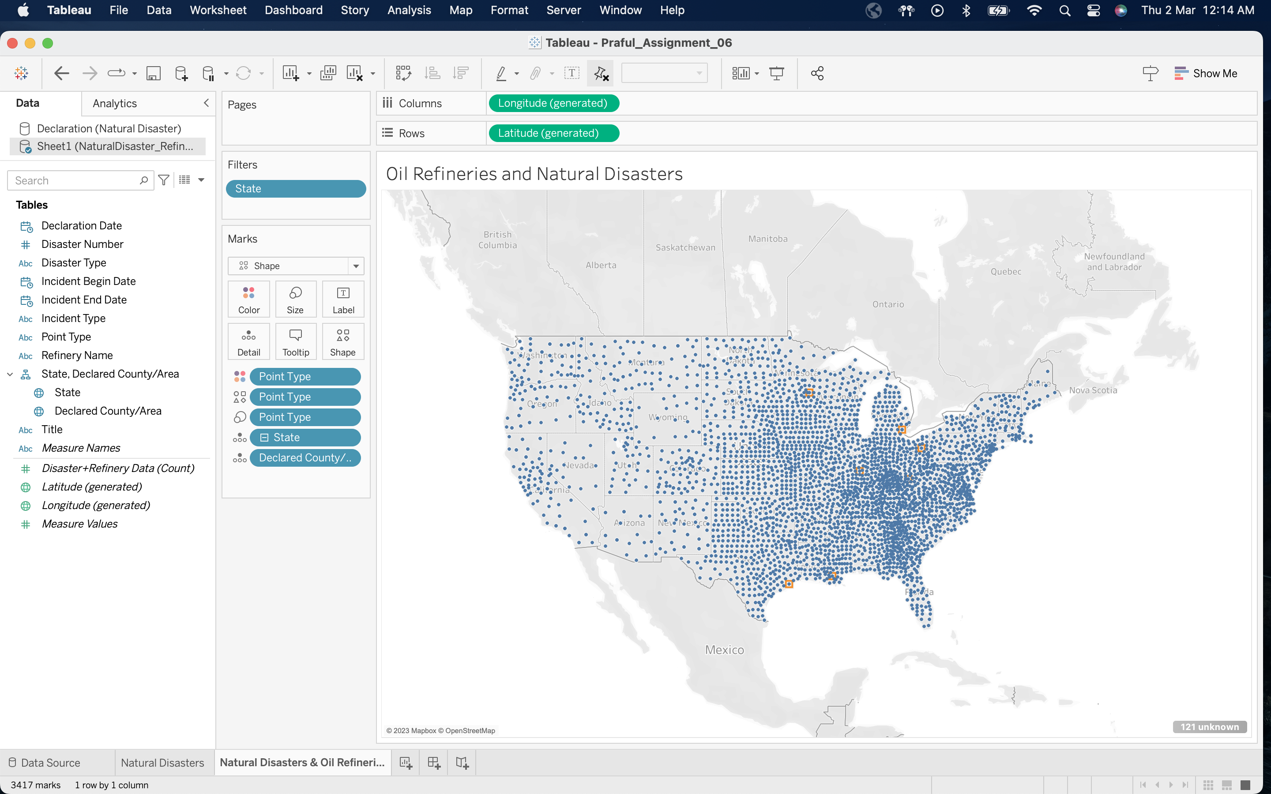

**Question K**

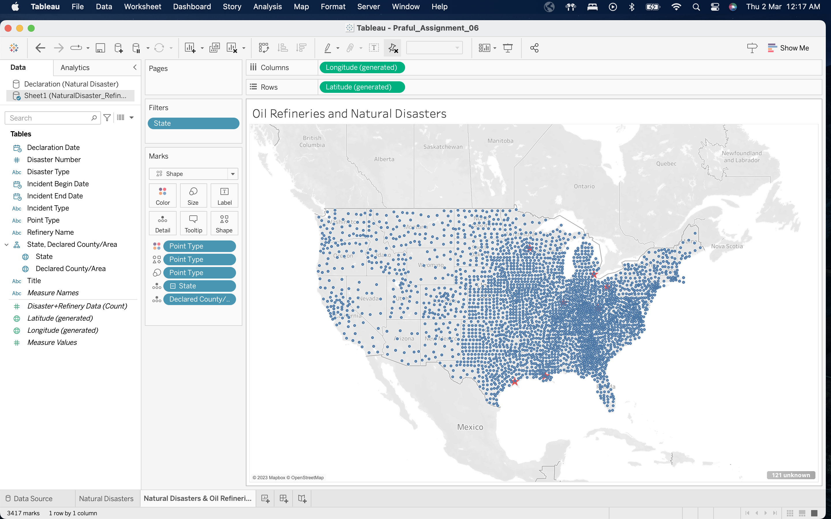

**Question L**

1. Texas
2. Minnesota
3. Illinois
4. Kentucky
5. Ohio
6. Michigan
7. Louisiana

**Question M**

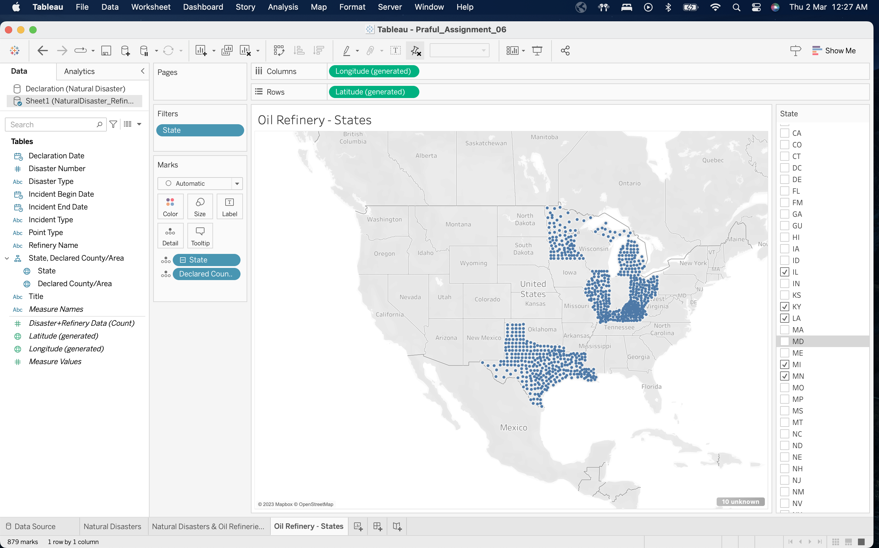

**Question N**

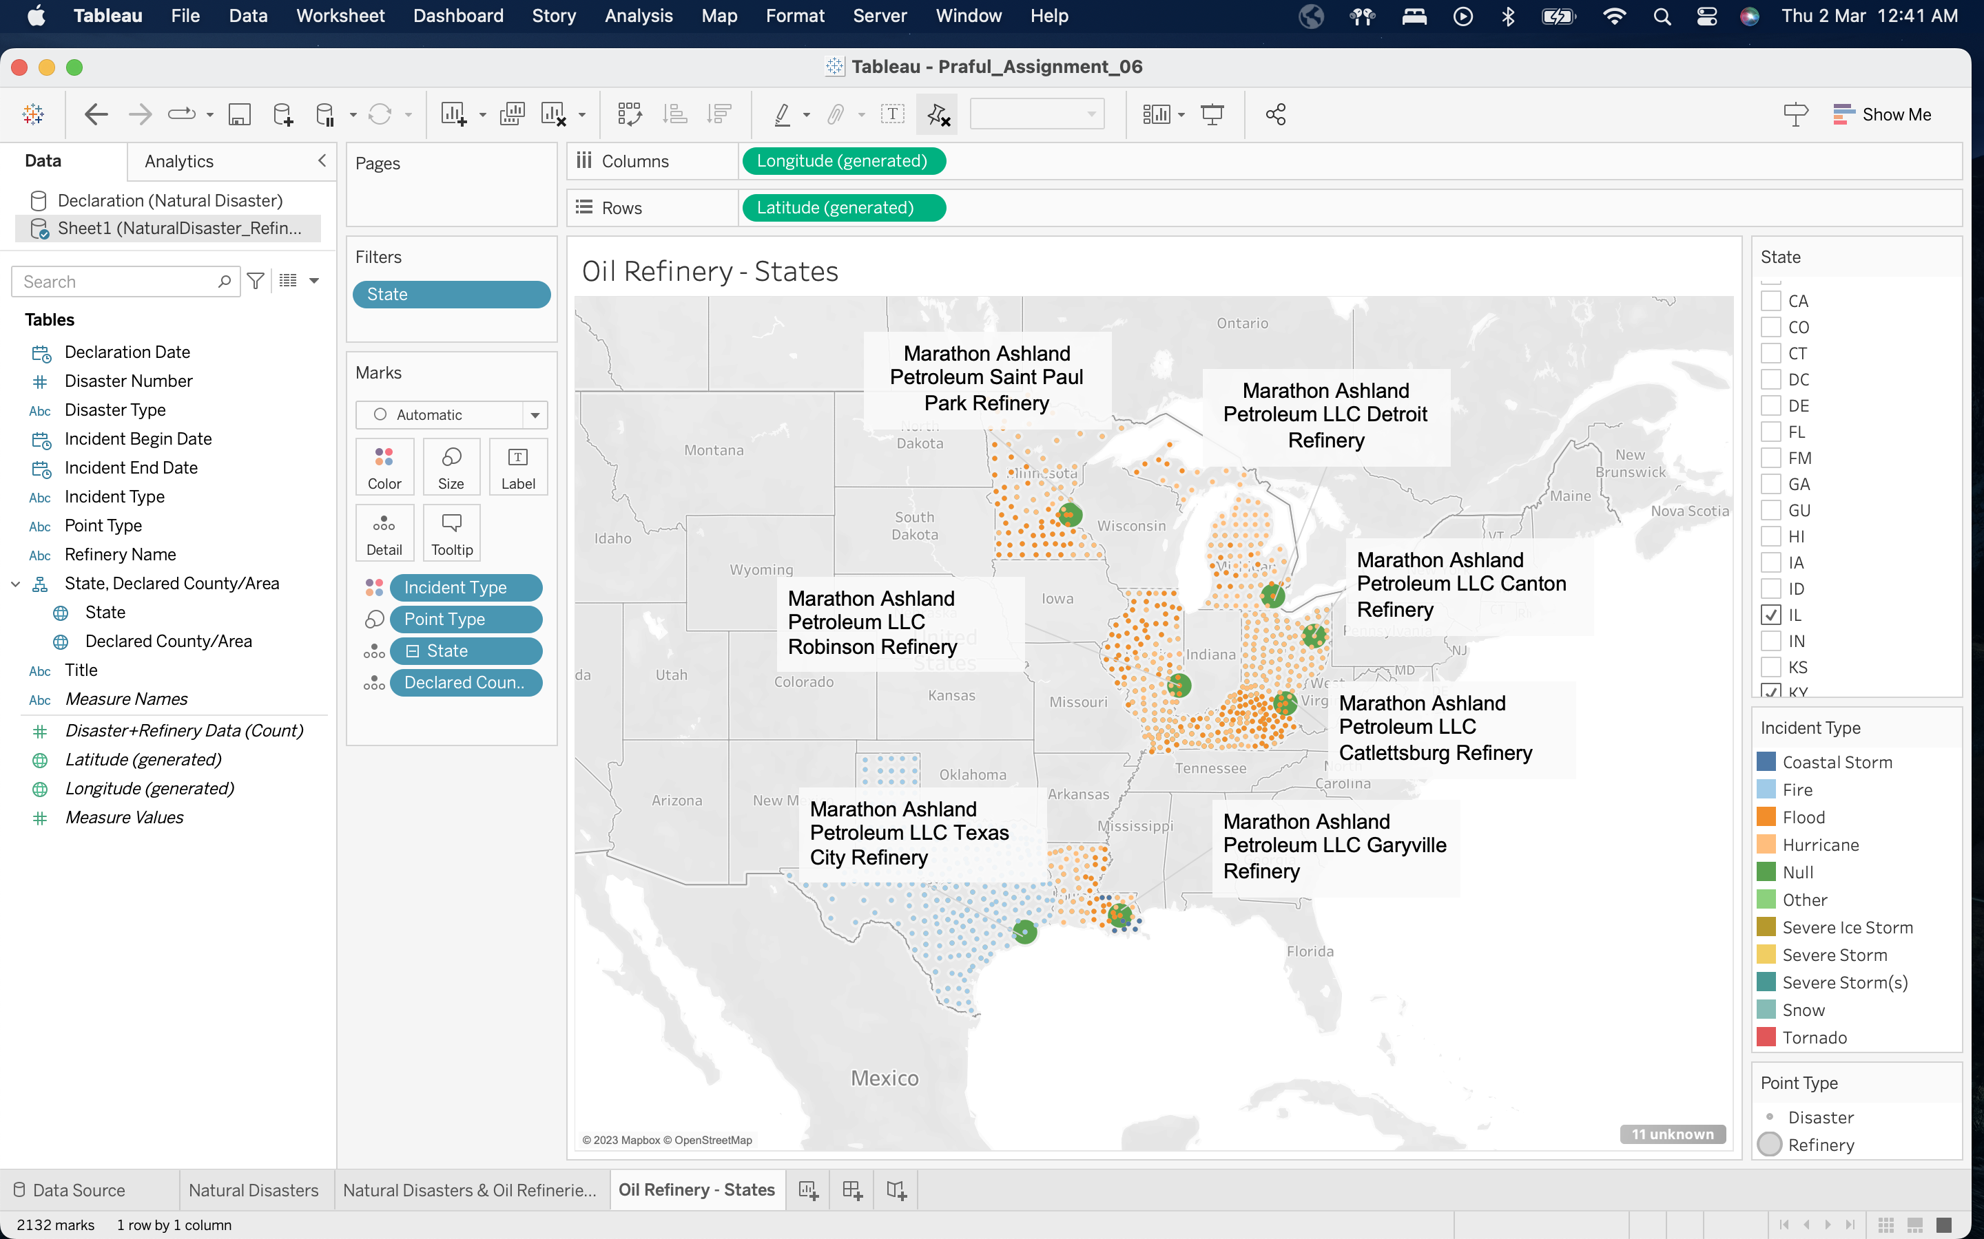

**Question O**

The disasters impacting Louisiana are:

* Flood
* Coastal Storm
* Hurricane

The disasters impacting Kentucky are:

* Flood
* Hurricane

**Question P**

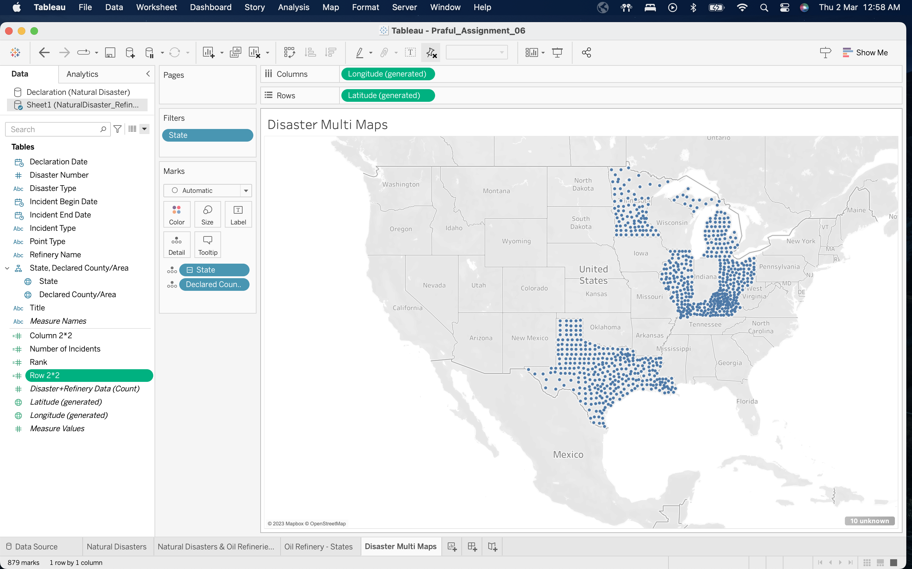

**Question Q**

**Considering states with the selected refineries:**

Hurricane is ranked 1st

**Considering all the states:**

Severe Storm(s) is ranked 1st

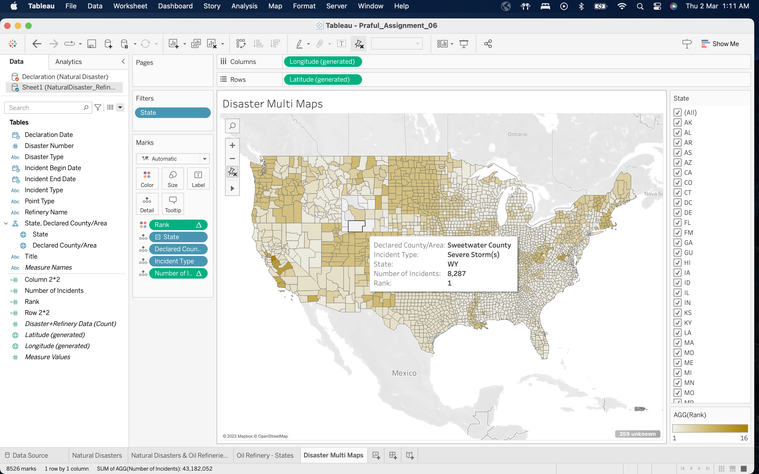

**Question R**

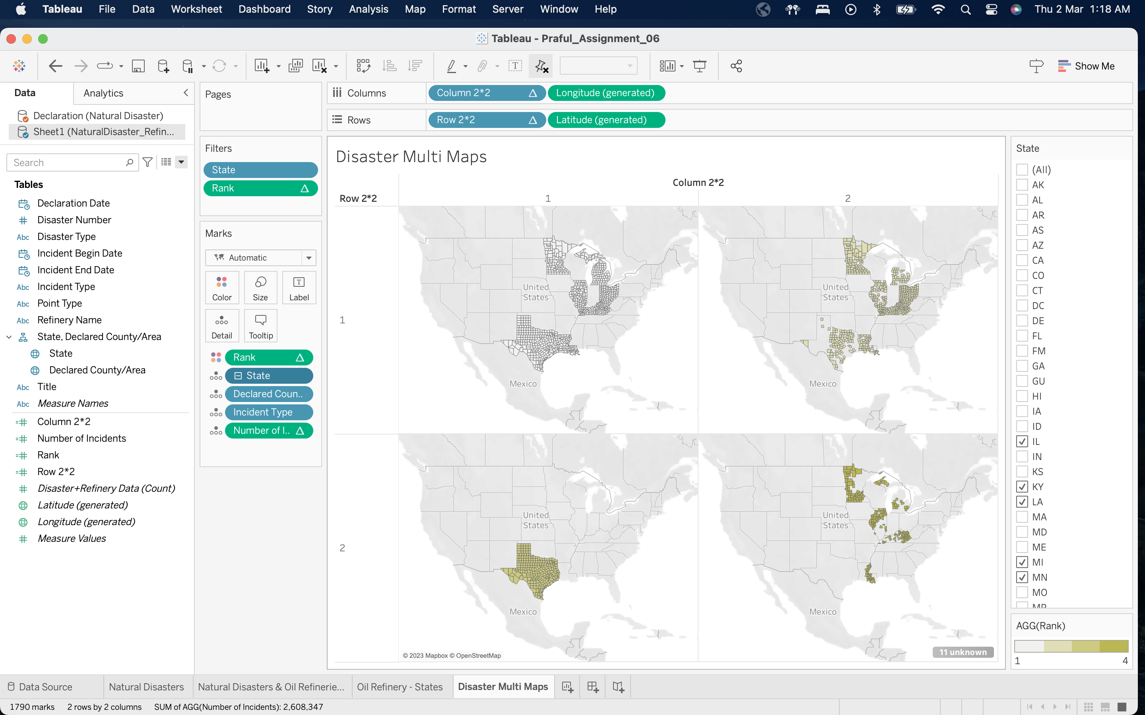

**Question S**

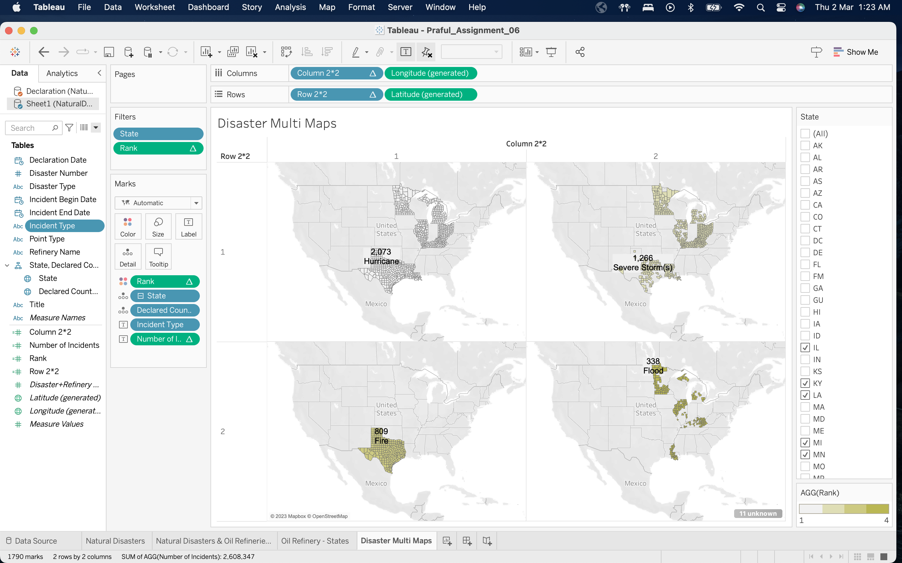

**Question T**

The calculated fields generate quantitative values and hence got added as Measures.

**Question U**

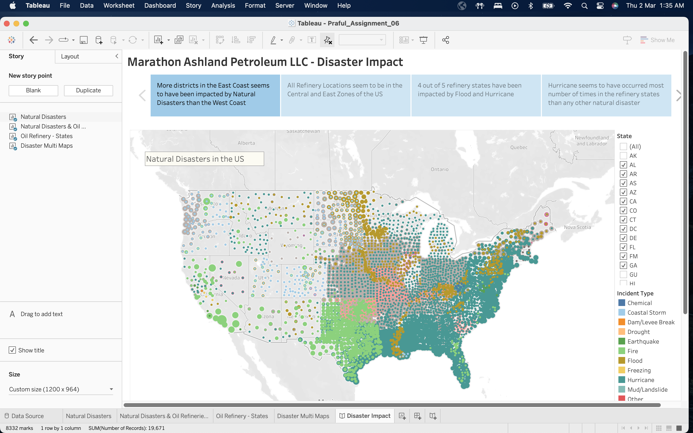

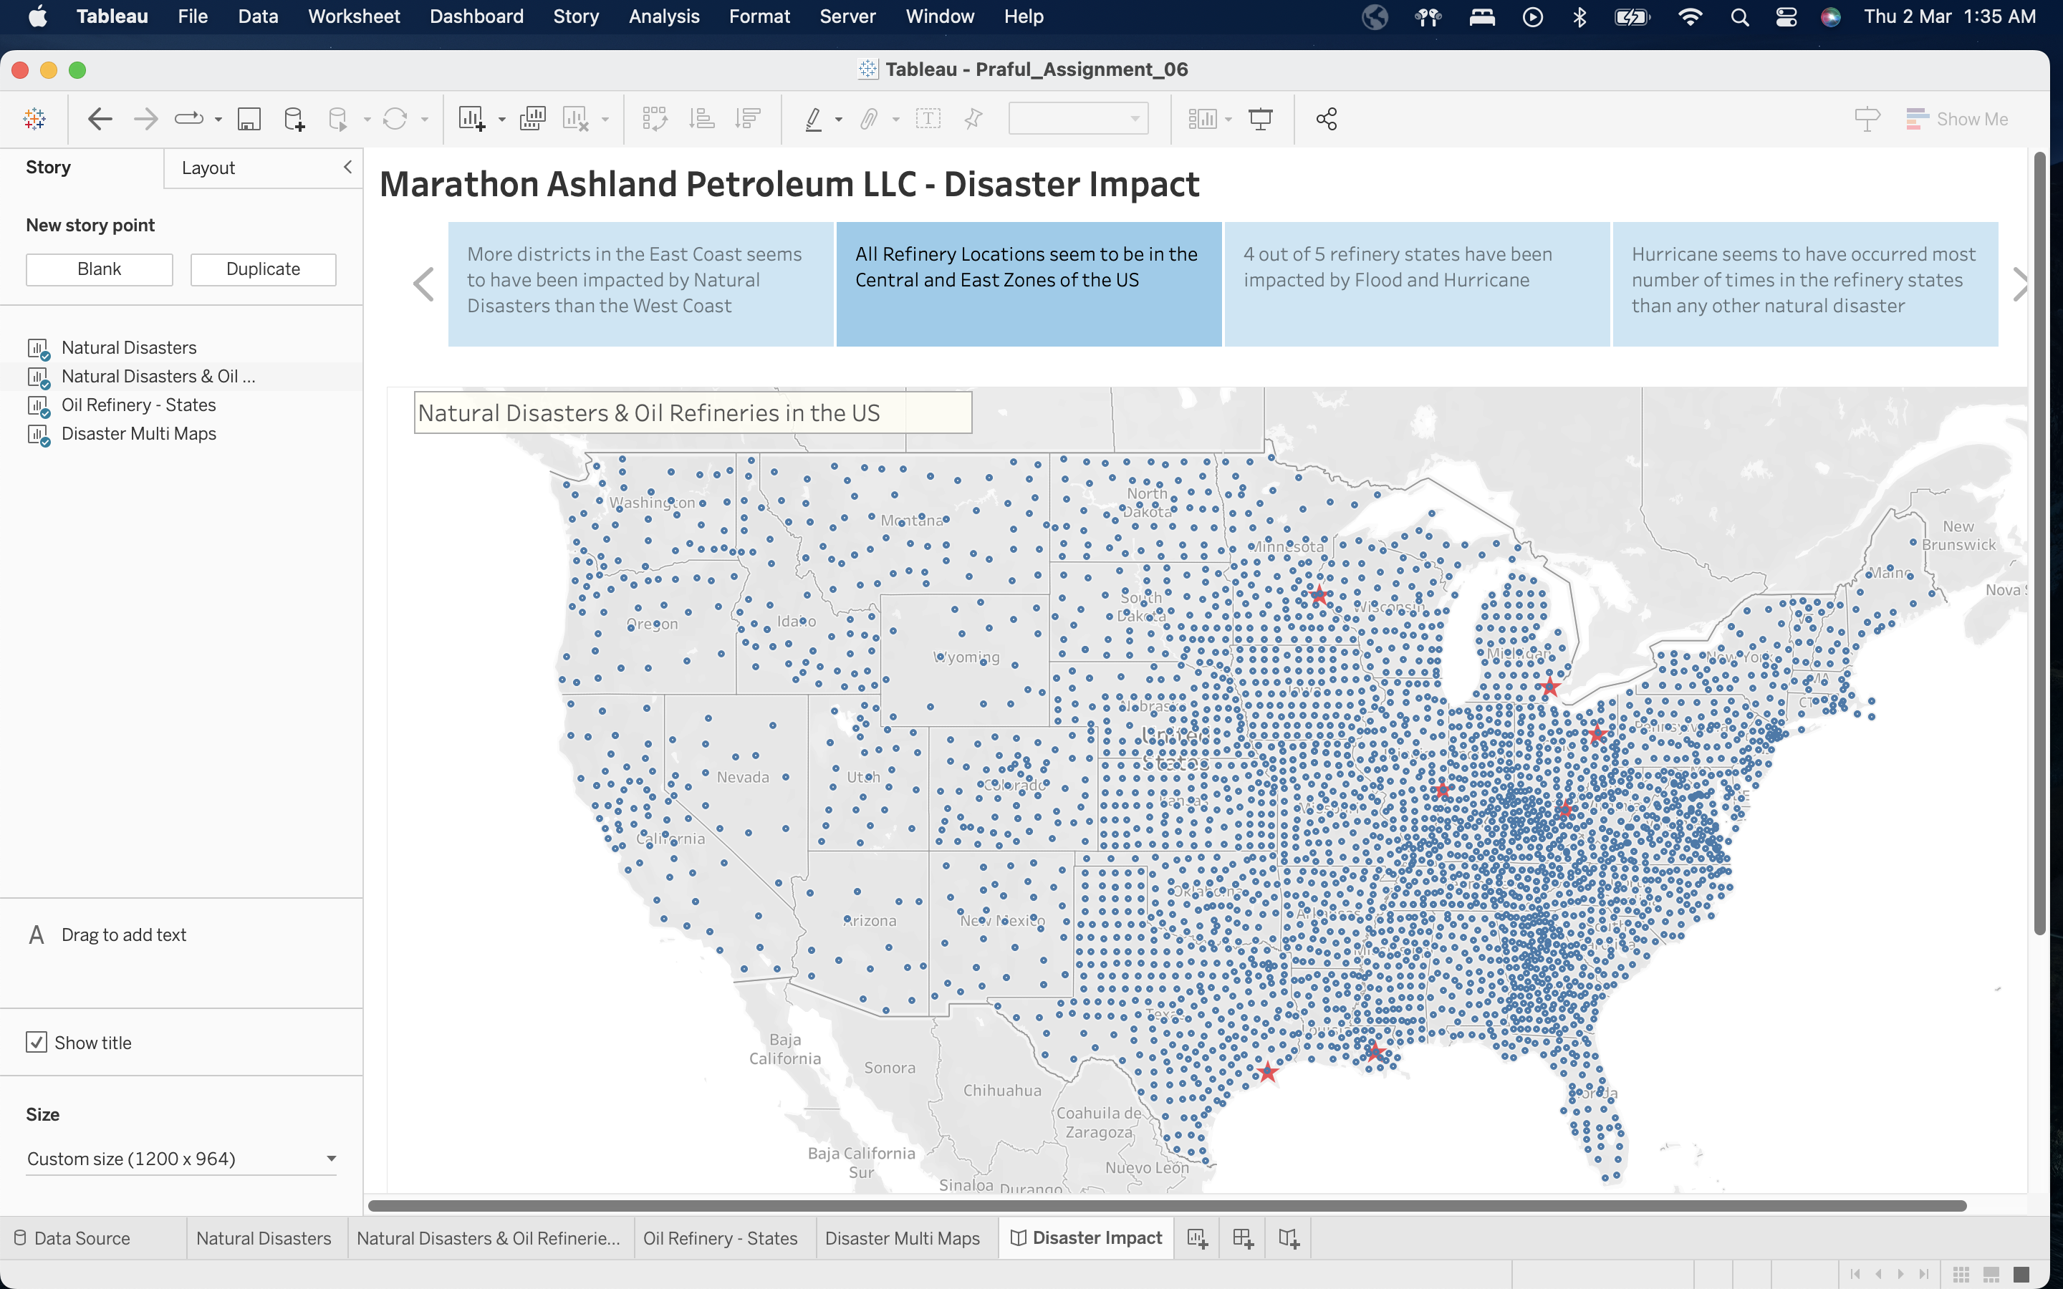

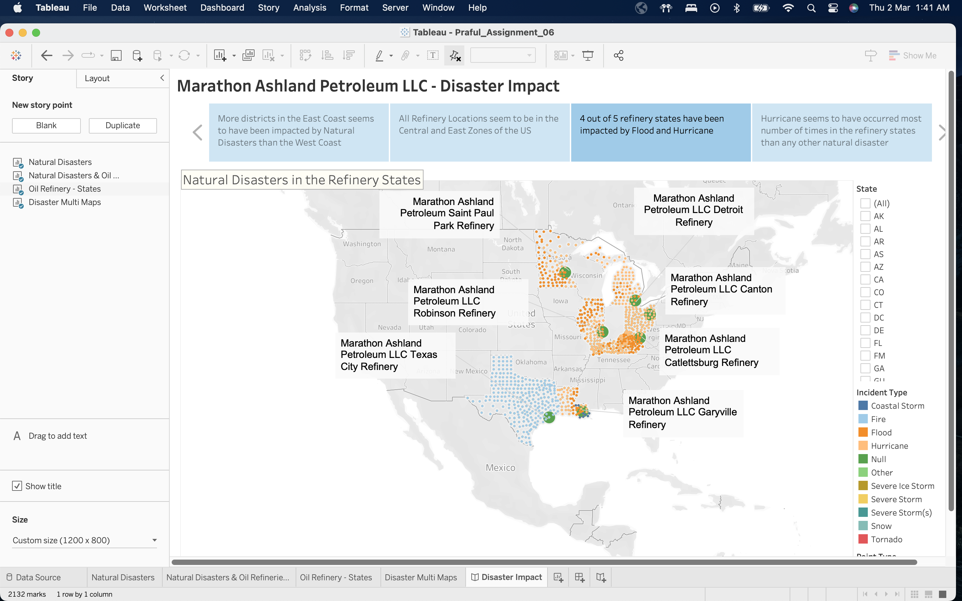

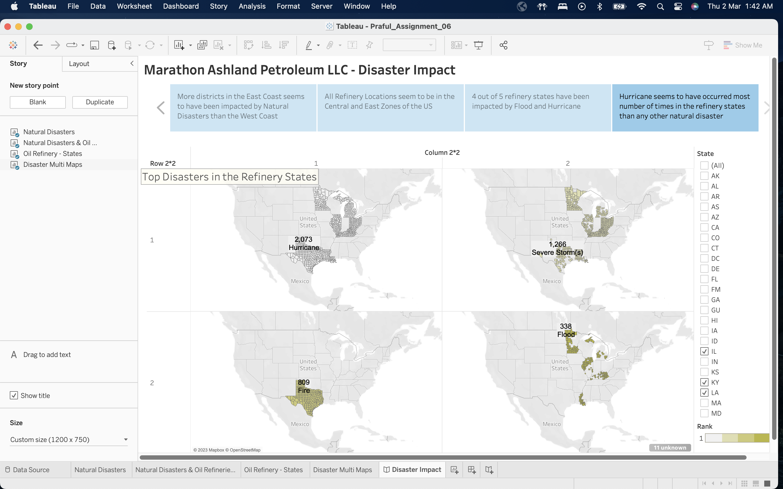

**Question V**

The language employed was logical, as we began by envisioning natural calamities in the US and then gradually zoomed in on the states where the chosen oil refineries were situated. This approach of logical rhetoric is fitting for our purposes as we are examining statistics like the frequency of particular disasters and using them to determine the most significant disasters in our refinery areas. We proceeded in a logical sequence, ultimately identifying the leading disasters in these regions.